Cloud Computing Report

Cloud Computing in Education

Mark Lopes(9913)

Chapter 1

Introduction

Cloud computing has transformed various industries, including education, by providing scalable, cost-effective, and accessible solutions. With the increasing demand for digital learning and remote education, cloud-based technologies have become essential. Cloud computing allows educational institutions to store and process data remotely, enabling real-time collaboration, virtual classrooms, and AI-driven personalized learning experiences. This report explores the impact of cloud computing in the education sector, analyzing its applications, benefits, challenges, and future trends.



Chapter 2

Applications and Use Cases

2.1 Online Learning Platforms

* Cloud-based platforms like Google Classroom, Coursera, and Udemy provide on-demand access to educational content, allowing students to learn at their own pace. These platforms support multimedia content, quizzes, and certifications, making learning more engaging and effective. Cloud storage ensures that materials are always accessible and updated in real time.

  

2.2 Virtual Classrooms

* Applications such as Zoom, Microsoft Teams, and Google Meet enable real-time interaction between students and teachers, bridging the gap in remote education. These platforms support video conferencing, screen sharing, and collaborative tools like whiteboards and breakout rooms, enhancing the virtual learning experience.

  

2.3 Cloud Storage & Collaboration

* Google Drive, Dropbox, and OneDrive allow students and educators to store and share academic materials, facilitating teamwork and seamless collaboration. Documents, presentations, and spreadsheets can be edited in real time, ensuring up-to-date and synchronized work among students and faculty members.

 

Chapter 3

Benefits of Cloud Computing in Education

**3.1 Cost Efficiency**

* Cloud services reduce the need for physical infrastructure, such as servers and data centers, lowering operational costs for institutions. Subscription-based cloud models allow schools and universities to pay for only what they use, optimizing budget management.

**3.2 Scalability**

* Cloud solutions can easily scale up or down depending on institutional needs. Whether accommodating a few hundred students or millions of users worldwide, cloud providers can allocate resources dynamically to meet demand.

**3.3 Accessibility**

* Cloud-based learning enables access to educational resources from anywhere with an internet connection. This benefits students in remote areas, professionals seeking flexible learning options, and institutions offering distance education programs.

**3.4 Collaboration & Engagement**

* Cloud technology enhances teamwork through real-time document sharing, discussions, and project collaboration. Interactive tools such as shared workspaces, discussion forums, and cloud-based coding environments allow students and teachers to work together seamlessly.

**3.5 Security & Backup**

* Cloud services provide automated backups and disaster recovery options, preventing data loss. Encryption, multi-factor authentication, and compliance with security regulations help protect sensitive student and faculty data from cyber threats.

Chapter 4

**4. Challenges and Limitations**

**4.1 Data Privacy & Security Concerns**

* Storing sensitive student and faculty data in the cloud raises privacy and security risks. Institutions must ensure compliance with regulations like GDPR and FERPA and implement robust security measures to protect against cyber threats.

**4.2 Internet Dependency**

* Cloud-based education relies heavily on stable internet connectivity. Students in rural or underdeveloped areas may face challenges in accessing online classes and resources due to poor internet infrastructure.

**4.3 Adoption Barriers**

* Some educational institutions face resistance to transitioning from traditional teaching methods to cloud-based solutions. This resistance may stem from a lack of digital literacy among educators and students or concerns over data control and reliability.

**4.4 Cost of Subscription Services**

* While cloud computing reduces hardware costs, premium cloud services, such as AI-driven learning platforms or high-performance research computing, can be expensive. Institutions must balance affordability with access to high-quality educational tools.

**Chapter 5**

**Regulatory Considerations**

**5.1 GDPR (General Data Protection Regulation)**

* Protects student data privacy in European institutions by regulating how personal information is collected, stored, and processed. Cloud service providers must comply with GDPR to ensure data security and user privacy.

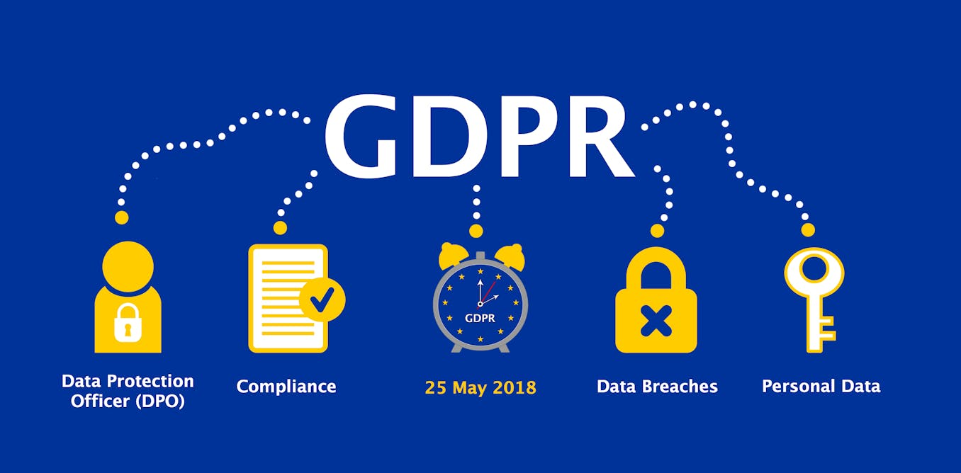

**5.2 FERPA (Family Educational Rights and Privacy Act, US)**

* Ensures the confidentiality of student records and grants students and parents control over their education data. Schools using cloud services must ensure compliance with FERPA requirements.



**Chapter 6**

**Conclusion**

Cloud computing has significantly improved education by making learning more accessible, cost-effective, and efficient. The adoption of cloud technologies in education has revolutionized how students learn, collaborate, and interact with educational content. Despite challenges such as data security and internet dependency, continuous advancements in AI, blockchain, and hybrid cloud solutions will further enhance the education sector. As cloud technology evolves, its role in shaping the future of education will become even more prominent, ensuring that learning is more flexible, inclusive, and effective.

<https://www.researchandmarkets.com/report/educational-cloud-computing>

<https://elearningindustry.com/benefits-and-challenges-of-cloud-computing-in-education>